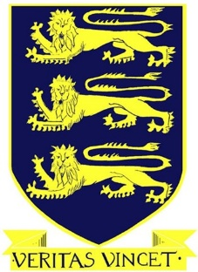

Free School Meals / School Uniform and
Physical Education Clothing Allowance
2021 / 2022

We would like to provide you with an update on the 2021 / 22 application process for
Free School Meals and School Uniform / Physical Education Clothing Allowances.

The Education Authority (EA) will be issuing communications on the EA website and social media channels to inform Parents / Guardians of Free School Meals and Clothing Allowances. We encourage all potential applicants to apply for the support available.

Current Eligible Families and New Applicants
Parents / Guardians who are currently in receipt of FSM support for the 2020 / 21 school year will NOT BE SENT A PRE-POPULATED FORM FOR THE 2021 / 22 SCHOOL YEAR.
All Parents / Guardians (including new applicants) are now required to apply on-line from Monday 7th June 2021 via the EA website https://www.eani.org.uk/financial-help/free-school-meals.
It is recommended that Parents / Guardians apply during the month of June to enable applications to be processed and be in place for your child for the new school year.
Special Diet
Parents / Guardians whose child has a Statement of Special Educational Needs (Stage 5) and requires a special diet should contact the Meals and Uniform Section for a paper application form if they wish to apply under the special diet criteria.
Free School Meals / Uniform Grants Helpdesk
The Free Schools Meals and Uniform Grants Helpdesk is operated by staff across the EA Free School Meals/ Uniform Grants service. It is available to assist Parents / Guardians and schools who may have any queries.

The Helpdesk operates Monday – Friday from 9.00am to 4.30pm and can be contacted via email: mealsanduniform@eani.org.uk.

The telephone number to be used for all enquiries is: 028 9041 8044

Further information including eligibility criteria for the 2021 / 22 school year and a list of Frequently Asked Questions to assist with any parental queries can be accessed by logging onto www.eani.org.uk/financial-help/free-school-meals.

